FINAL INDIVIDUAL COURSEWORK REPORT
Vehicle-Centric Sensing for Bridge Condition Monitoring
Time- and Frequency-Domain Investigation of Dataset B - Bridge Condition Effect
ZJUT 2026 International Summer Course
Vehicle-Centric Sensing (V2X)
Student
AL-DHANEBI ABDULMAJEED TAWFIK AHMED YAHYA
Student ID: 312024705005
Engineering question: Can changes in bridge structural condition be identified from vehicle responses?

1. Introduction
Bridge condition assessment is an important part of transportation-infrastructure management because deterioration can reduce structural performance while visual inspection alone may not reveal changes in dynamic behaviour. Conventional structural health monitoring (SHM) typically places sensors directly on a bridge; however, instrumenting large numbers of short- and medium-span bridges can be costly and operationally difficult. Indirect or drive-by bridge monitoring addresses this problem by using an instrumented passing vehicle as a mobile sensor, allowing bridge-related information to be inferred from the vehicle response (Malekjafarian et al., 2015; Malekjafarian et al., 2022).
The physical basis is vehicle-bridge interaction (VBI). A moving vehicle excites the bridge through its wheel loads, the bridge vibrates, and that bridge motion acts back on the vehicle. Consequently, vehicle acceleration can contain components related to both the vehicle and the bridge. The original drive-by concept demonstrated that bridge frequencies can be extracted from a passing-vehicle response, establishing the basis for frequency-based indirect monitoring (Yang et al., 2004).
This report investigates Dataset B - Bridge Condition Effect. The vehicle speed is held at 5 m/s while the dataset damage parameter is increased from 0% to 50%. The central engineering question is whether changes in bridge structural condition can be detected not only in a direct bridge acceleration channel but also in vehicle-based sprung-mass, unsprung-mass and contact-point responses. Peak acceleration and root-mean-square (RMS) acceleration are used in the time domain, while fast Fourier transform (FFT) spectra are used to identify bridge-related frequency components.
The objectives are to: (1) characterise the direct and indirect acceleration responses; (2) quantify changes in peak and RMS acceleration; (3) identify and compare bridge-related frequency components; (4) assess the sensitivity of different response channels to bridge-condition change; and (5) discuss the reliability, limitations and implications of the results for practical Vehicle-Centric Sensing and drive-by SHM.

2. Theoretical Background

2.1 Vehicle-Centric Sensing
Vehicle-Centric Sensing uses sensors carried by vehicles to observe the vehicle, road environment and infrastructure during normal movement. In bridge applications, accelerometers or other sensors mounted on a moving vehicle can act as mobile sensing units. The key advantage is mobility: one or more instrumented vehicles can repeatedly pass over multiple bridges rather than requiring a permanent sensor installation on every structure. Recent reviews describe this approach as mobile sensing, indirect monitoring or drive-by bridge monitoring and emphasise its potential for lower-cost network-scale condition assessment (Malekjafarian et al., 2022).

2.2 Vehicle-to-Everything (V2X)
V2X describes communication between a vehicle and other entities in the transportation system. Hussein et al. (2022) distinguish vehicle-to-vehicle (V2V) communication and vehicle-to-infrastructure (V2I) communication, while the wider V2X concept allows vehicles to communicate with surrounding infrastructure and other connected entities. In a future infrastructure-monitoring workflow, vehicle-sensed bridge features could be transmitted through V2I/V2X links to roadside units, cloud services or infrastructure operators. The present dataset does not simulate communication performance; V2X is therefore treated here as the system-level communication layer that could carry the condition information extracted from vehicle responses.

2.3 Vehicle-Bridge Interaction (VBI)
VBI is the coupled dynamic interaction that occurs while a vehicle crosses a bridge. The vehicle applies a moving load to the bridge, the bridge develops a dynamic response, and the resulting deck displacement influences the tyre and suspension motion. Therefore, vehicle acceleration is not solely a vehicle property: it also contains information transmitted from the supporting bridge. Malekjafarian et al. (2015) describe the passing vehicle as both an exciter and a receiver of bridge dynamics, which provides the theoretical basis for indirect bridge monitoring.
If structural condition changes reduce bridge stiffness, the bridge dynamic characteristics can also change. In vibration-based SHM, natural-frequency changes are widely used as condition indicators because modal frequencies depend on the system mass and stiffness. For a simple single-degree-of-freedom analogy, the relationship is:
f_n = (1 / 2π) √(k / m)
A real bridge is a distributed system, so its modal frequencies depend on the spatial distribution of stiffness, mass, boundary conditions and mode shapes. Nevertheless, a systematic reduction in effective stiffness is generally expected to reduce natural frequencies when the other governing properties are unchanged. This principle is directly relevant to Dataset B, where the prescribed bridge-condition cases have progressively lower theoretical first natural frequencies.

2.4 Quarter-Car Model
A simplified quarter-car model is commonly used to explain drive-by monitoring. The sprung mass m_s represents the vehicle-body contribution, while the unsprung mass m_u represents the wheel/axle assembly. They are connected by suspension stiffness k_s and damping c_s, and the tyre is represented by stiffness k_t. The tyre interacts with the road profile r(x) and bridge displacement y_b(x,t). A representative VBI model is shown in Figure 1.
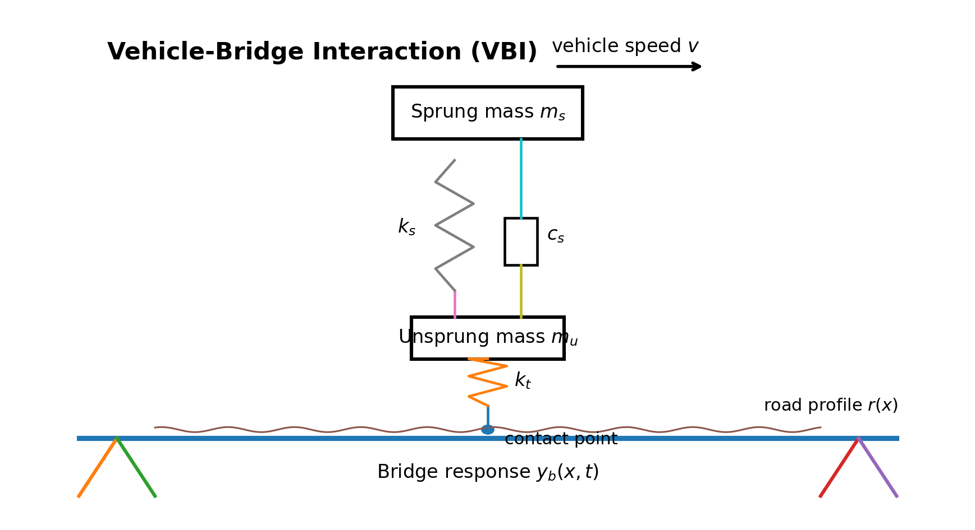
Figure 1. Simplified quarter-car vehicle-bridge interaction model used to explain the measured sprung-mass, unsprung-mass and contact-point responses.
Using the notation of Malekjafarian et al. (2015), the vertical equations of motion can be written in simplified form as:
m_s ÿ_s + c_s(ẏ_s - ẏ_u) + k_s(y_s - y_u) = 0 (1)
m_u ÿ_u - c_s(ẏ_s - ẏ_u) - k_s(y_s - y_u) + k_t(y_u - y_b - r) = 0 (2)
The bridge displacement term y_b appears in the unsprung-mass equation, showing mathematically how changes in bridge vibration can enter the vehicle response. In the dataset, SprungAcc_mps2 corresponds to the sprung response, UnsprungAcc_mps2 to the unsprung response, and CPAcc_mps2 to the tyre/bridge contact-point response.

2.5 Drive-by Structural Health Monitoring
Drive-by SHM seeks to infer bridge properties from sensors carried by a passing vehicle instead of relying entirely on bridge-mounted instrumentation. Yang et al. (2004) demonstrated theoretically that bridge-frequency information can be extracted from a passing-vehicle acceleration response, while subsequent work has extended the concept to mode shapes, damping and damage-sensitive features. The approach offers potential advantages in mobility, inspection cost and network coverage (Malekjafarian et al., 2015; Malekjafarian et al., 2022).
Practical implementation remains challenging. Road roughness may excite vehicle-related components that mask bridge information, the vehicle remains on the bridge for only a limited interaction time, measurement noise can reduce feature reliability, and environmental or operational changes may cause frequency variations that can be confused with damage. These limitations mean that a single frequency change should not automatically be interpreted as damage in field monitoring. In the controlled Dataset B analysis, however, vehicle speed and road profile are held fixed across the condition cases, allowing the response trends to be interpreted primarily in relation to the prescribed bridge-condition change.

3. Dataset and Methodology

3.1 Dataset B - Bridge Condition Effect
Dataset B contains six bridge-condition cases labelled Damage_00pct to Damage_50pct. The vehicle travels at a constant 5 m/s, the bridge length is 15 m, and the bridge-condition change is centred at 7.5 m. The sampled response interval is 0.001 s, corresponding to a sampling frequency of 1000 Hz. The direct bridge response used in this report is the vertical acceleration channel at x = 7 m, close to the prescribed condition-change location. Indirect responses are the sprung-mass, unsprung-mass and contact-point accelerations.
The dataset distinguishes the case label DamageParameter_pct from MaximumLocalEI_Loss_pct. These are not numerically identical; for example, the 50% damage-parameter case has a reported maximum local EI loss of 83.61%. The report therefore uses the dataset damage parameter as the case label and reports the EI-loss metadata separately rather than treating the two quantities as interchangeable.
Damage parameter (%) | Maximum local EI loss (%) | Damage location (m) | Vehicle speed (m/s) | Theoretical first bridge frequency (Hz)
0 | 0.00 | 7.5 | 5.0 | 5.6553
10 | 25.90 | 7.5 | 5.0 | 5.5204
20 | 46.63 | 7.5 | 5.0 | 5.3662
30 | 62.78 | 7.5 | 5.0 | 5.1903
40 | 74.92 | 7.5 | 5.0 | 4.9909
50 | 83.61 | 7.5 | 5.0 | 4.7671
Table 1. Dataset B bridge-condition cases and supplied theoretical first natural frequencies.

3.2 Selected Response Channels
Four acceleration channels are compared: (i) direct bridge acceleration at x = 7 m; (ii) sprung-mass acceleration; (iii) unsprung-mass acceleration; and (iv) contact-point acceleration. The bridge channel provides the most direct structural measurement. The three vehicle channels test whether condition-sensitive bridge information is also observable indirectly, which is the central requirement for Vehicle-Centric Sensing.

3.3 Time-Domain Analysis
Peak absolute acceleration and RMS acceleration were calculated over the vehicle-on-bridge interval, defined by bridge-relative position from 0 to 15 m. Peak acceleration characterises the most extreme instantaneous response, while RMS represents the overall response magnitude over the crossing interval:
a_peak = max |a_i| (3)
a_RMS = √[(1/N) Σ a_i²] (4)

3.4 Frequency-Domain Analysis
For the FFT analysis, each signal was linearly detrended and multiplied by a Hann window to reduce spectral leakage. A coherent-gain correction was applied to the single-sided amplitude spectrum, and zero-padding to at least 2^16 samples was used to provide a smooth frequency display. Zero-padding does not increase the true frequency resolution. The bridge-related component was identified as the largest FFT amplitude within the 4.5-7.0 Hz search band. The direct bridge FFT used the full bridge-response record, while the vehicle FFTs used the vehicle-on-bridge interval only. This distinction is retained when interpreting absolute FFT amplitudes.

4. Results

4.1 Dataset Visualisation and Time Histories
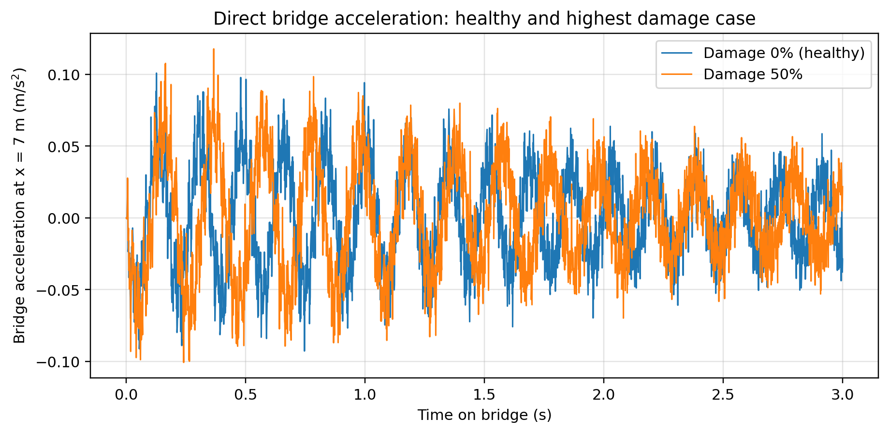
Figure 2. Direct bridge acceleration at x = 7 m for the healthy (0%) and highest damage-parameter (50%) cases during the vehicle crossing.
Figure 2 shows that both condition cases contain oscillatory bridge response throughout the crossing, but the detailed waveform and response envelope change as the prescribed bridge condition changes. The maximum absolute bridge acceleration is 0.100851 m/s² for the healthy case and 0.117748 m/s² for the 50% case. However, the peak response is not monotonic across all six cases, so peak acceleration alone is not a reliable measure of damage severity.
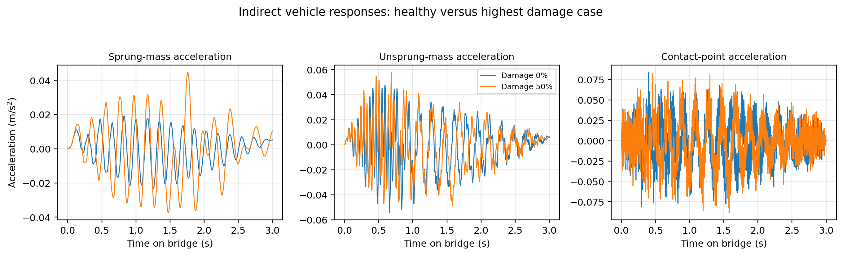
Figure 3. Indirect sprung-mass, unsprung-mass and contact-point acceleration responses for the healthy and 50% damage-parameter cases.
The indirect responses show different sensitivities. The sprung-mass signal changes visibly between the healthy and 50% cases, whereas the unsprung-mass and contact-point response magnitudes are more similar. This difference is quantified by RMS analysis in Section 4.2.

4.2 Time-Domain Analysis
Damage (%) | Bridge peak | Bridge RMS | Sprung RMS | Unsprung RMS | CP RMS
0 | 0.100851 | 0.032800 | 0.009884 | 0.018483 | 0.025658
10 | 0.097010 | 0.033389 | 0.010556 | 0.018482 | 0.025725
20 | 0.105853 | 0.033933 | 0.011420 | 0.018432 | 0.025914
30 | 0.110529 | 0.034376 | 0.012633 | 0.018316 | 0.025887
40 | 0.099327 | 0.035431 | 0.014894 | 0.018600 | 0.026323
50 | 0.117748 | 0.036484 | 0.017878 | 0.018719 | 0.026659
Table 2. Time-domain acceleration indicators for Dataset B (all acceleration values in m/s²).
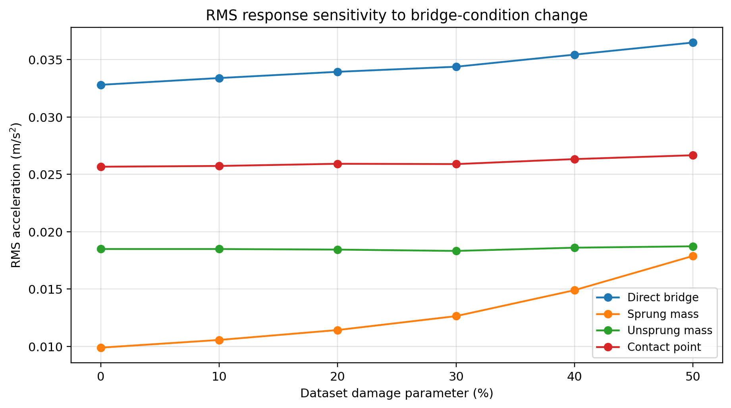
Figure 4. RMS acceleration versus Dataset B damage parameter for the direct bridge and three indirect vehicle-response channels.
The direct bridge RMS increases from 0.032800 to 0.036484 m/s² between the 0% and 50% cases, an increase of approximately 11.2%. The sprung-mass RMS increases much more strongly, from 0.009884 to 0.017878 m/s², an increase of approximately 80.9%. By comparison, unsprung-mass RMS changes by only about 1.3% and contact-point RMS by about 3.9%. The sprung-mass peak also increases from 0.023100 to 0.044754 m/s² (approximately 93.7%). Therefore, within this controlled dataset, the sprung-mass response is the most condition-sensitive of the indirect channels in the time domain, even though it has the smallest absolute acceleration magnitude.
The response-channel comparison also demonstrates that high signal amplitude is not equivalent to high structural-condition sensitivity. The contact-point acceleration is larger than the sprung-mass acceleration, but its RMS changes only slightly with bridge condition. This is important for practical sensor selection: a useful monitoring channel must respond systematically to the structural feature of interest, not merely exhibit a large vibration magnitude.

4.3 Frequency-Domain Analysis
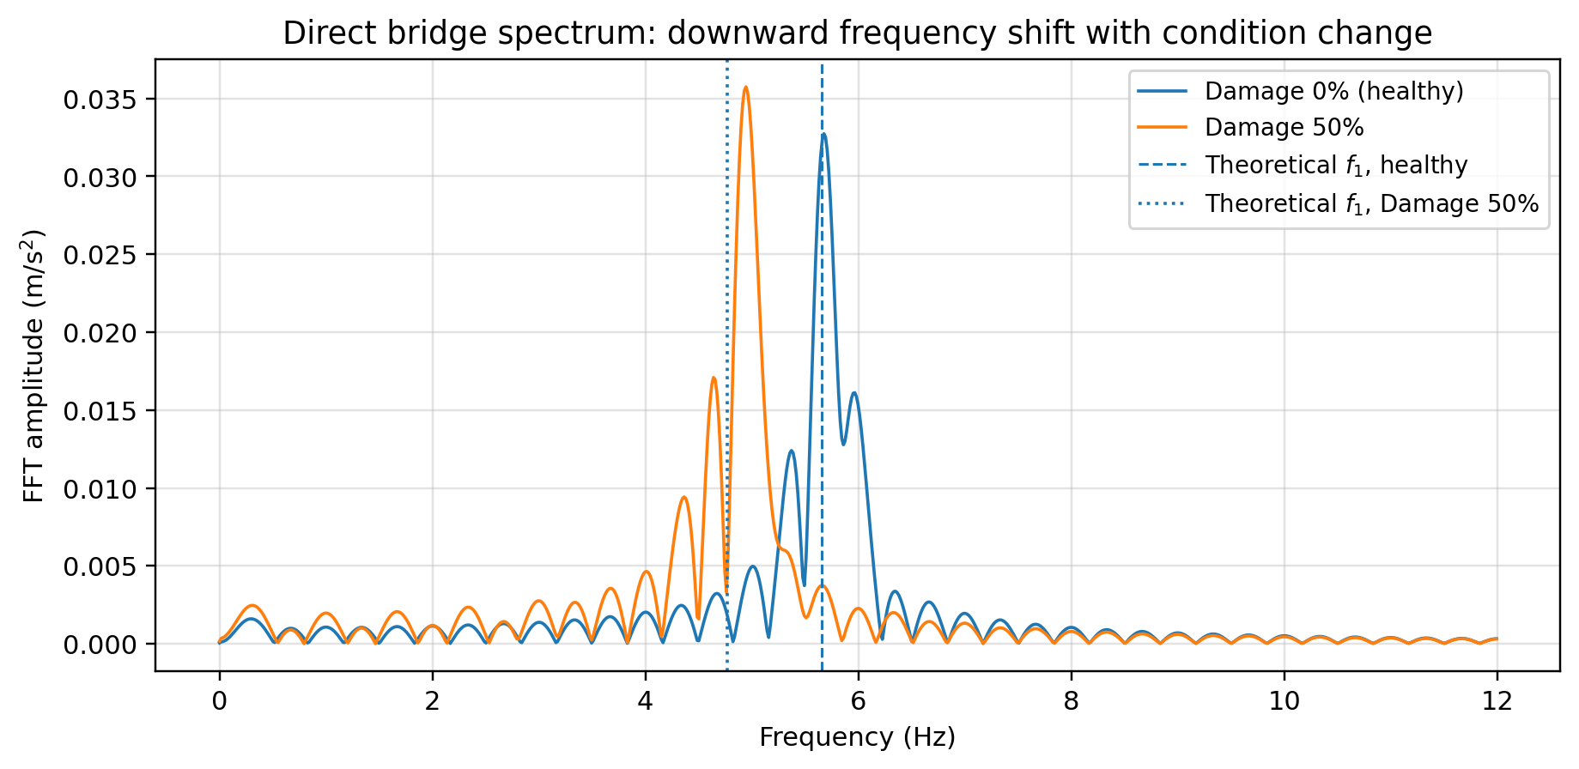
Figure 5. Direct bridge FFT spectra for the healthy and 50% damage-parameter cases. The supplied theoretical first natural frequencies are shown for comparison.
Figure 5 provides the clearest evidence of bridge-condition change. The theoretical first natural frequency decreases from 5.6553 Hz in the healthy case to 4.7671 Hz in the 50% case. The directly identified bridge-frequency component follows the same downward trend, decreasing from 5.6763 to 4.9438 Hz. This is a 12.9% decrease in the measured direct frequency, compared with a 15.7% decrease in the supplied theoretical value.
Damage (%) | Theory f1 | Bridge f1 | Sprung f1 | Unsprung f1 | CP f1 | Direct error (%)
0 | 5.6553 | 5.6763 | 5.7983 | 5.8136 | 5.7983 | 0.37
10 | 5.5204 | 5.6305 | 5.6763 | 5.6915 | 5.6763 | 1.99
20 | 5.3662 | 5.3558 | 5.5237 | 5.5542 | 5.5389 | 0.19
30 | 5.1903 | 5.2948 | 5.3711 | 5.3864 | 5.3711 | 2.01
40 | 4.9909 | 5.0201 | 5.1727 | 5.2032 | 5.1880 | 0.59
50 | 4.7671 | 4.9438 | 5.0049 | 5.0354 | 5.0049 | 3.71
Table 3. Theoretical and identified bridge-related frequencies (Hz). Direct error is relative to the supplied theoretical first natural frequency.
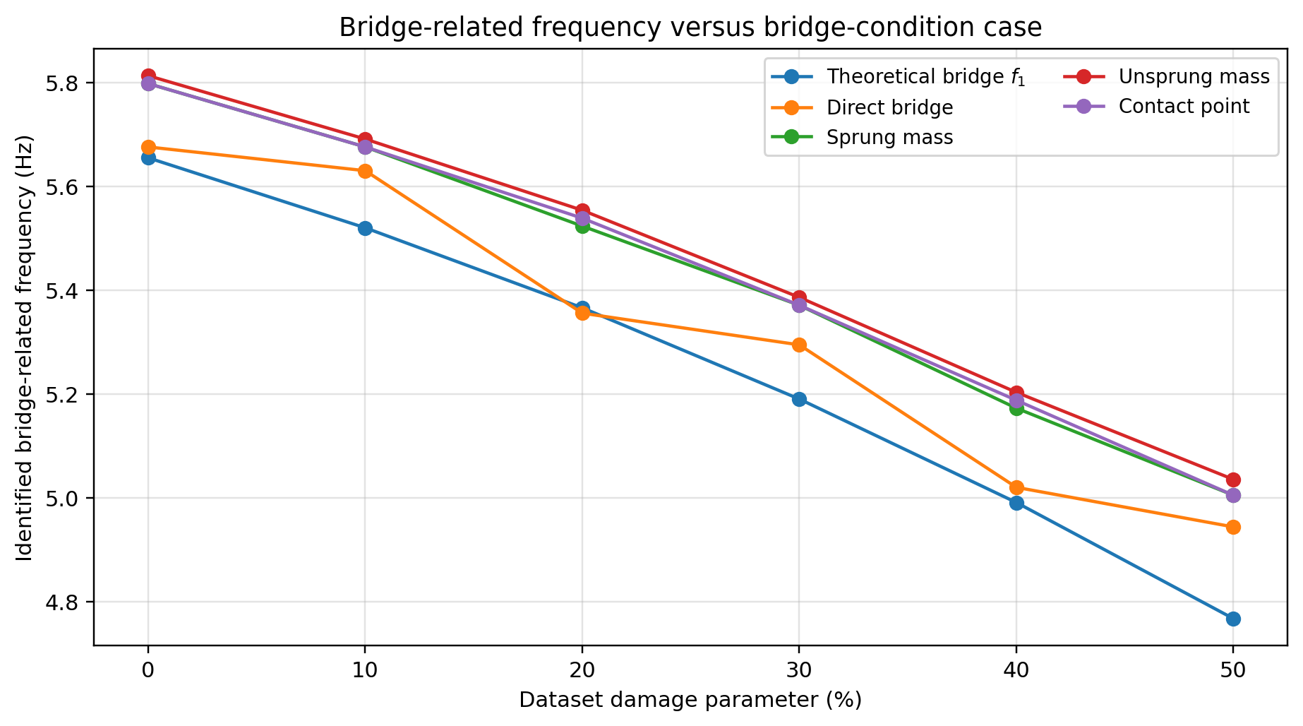
Figure 6. Theoretical first bridge natural frequency and identified bridge-related frequency components from the direct and indirect response channels.
All three vehicle channels also show a systematic downward shift. The sprung-mass identified component decreases from 5.7983 to 5.0049 Hz, the unsprung-mass component from 5.8136 to 5.0354 Hz, and the contact-point component from 5.7983 to 5.0049 Hz. The vehicle-based frequency estimates are consistently somewhat higher than the supplied theoretical bridge frequency, which is reasonable because the measured vehicle signal is a coupled VBI response rather than a pure bridge modal measurement. The direct bridge frequency agrees most closely with theory, with a mean absolute relative difference of approximately 1.48% across the six cases and a maximum difference of approximately 3.71%.

4.4 Response Comparison for Vehicle-Centric Sensing
The direct bridge channel provides the clearest structural-frequency estimate because it measures bridge acceleration directly, but it requires instrumentation on the structure. The sprung-mass response has a lower absolute amplitude but shows both a clear downward frequency trend and the strongest systematic RMS change with bridge condition, making it particularly informative for drive-by sensing in this dataset. The unsprung and contact-point channels also preserve the downward frequency trend, but their RMS values are much less sensitive to condition change. Their stronger tyre/road coupling may make them more susceptible to road-profile excitation in practical measurements.
For the purpose of the present engineering question, the sprung-mass channel therefore provides a useful compromise between practical vehicle-based measurement and structural-condition sensitivity. This conclusion is dataset-specific and should not be interpreted as a universal ranking of sensors for all bridges, vehicles or road profiles.

5. Discussion

5.1 Physical Interpretation of Bridge-Condition Change
The most consistent Dataset B feature is the downward frequency shift with increasing condition severity. The supplied maximum local EI loss increases from 0% to 83.61%, while the theoretical first natural frequency falls from 5.6553 to 4.7671 Hz. This behaviour is consistent with vibration-based SHM theory: a reduction in structural stiffness changes the dynamic properties and generally lowers modal frequency when mass and boundary conditions remain comparable. The measured bridge and vehicle responses reproduce the same direction of change, supporting a causal interpretation based on the prescribed stiffness deterioration rather than random variation.

5.2 Evidence Chain: Problem - Data - Analysis - Interpretation
The engineering problem is whether bridge-condition change can be detected using vehicle-centred measurements. The data provide controlled condition cases at fixed vehicle speed. Time-domain analysis shows that some response metrics, particularly sprung-mass RMS, are condition-sensitive, but direct peak acceleration is not monotonic. Frequency-domain analysis provides stronger evidence because the theoretical, direct and indirect bridge-related frequencies all move downward as condition severity increases. The agreement across multiple independent channels strengthens confidence that the change is related to the bridge rather than to a single noisy measurement. The resulting interpretation is that VBI transfers condition-sensitive bridge dynamics into the passing-vehicle response.

5.3 Reliability and Indicator Sensitivity
The frequency result is more reliable than a simple peak-based damage indicator in this dataset. Direct bridge peak acceleration varies non-monotonically, whereas the frequency trend is systematic and is reproduced by all four response channels. RMS is more stable than peak, but sensitivity depends strongly on the channel: sprung-mass RMS is highly responsive to the condition cases, while unsprung and contact-point RMS remain nearly constant. A monitoring strategy should therefore combine complementary indicators rather than depend on a single extreme value.

5.4 Limitations
Several limitations restrict direct transfer of these results to field deployment. First, Dataset B is a controlled numerical dataset with one vehicle model and a constant 5 m/s speed. Second, the vehicle remains on the bridge for a finite time, limiting frequency resolution of indirect measurements. Third, road roughness can excite vehicle components and mask bridge-related content, while measurement noise can disturb peak values and weaker spectral features. Fourth, environmental effects such as temperature can shift real bridge frequencies independently of damage. Finally, frequency reduction indicates a change in global dynamics but does not by itself uniquely identify damage location or mechanism. These limitations are consistent with the challenges identified in the drive-by monitoring literature (Malekjafarian et al., 2015; Malekjafarian et al., 2022).

5.5 Practical Implications for Vehicle-Centric Sensing and V2X
The results demonstrate a plausible end-to-end monitoring concept: a vehicle crosses a bridge, onboard accelerometers measure vehicle response, signal processing extracts condition-sensitive features, and these features can then be associated with the bridge and compared over repeated passages. In a connected-transport system, V2I/V2X communications could transmit the processed indicators to roadside or cloud infrastructure for network-level screening. Such a system would not replace detailed bridge inspection, but it could provide a scalable method for identifying structures that warrant closer assessment. Reliable field use would require repeated measurements, vehicle and speed normalisation, road-profile compensation, environmental baselines and robust data-quality control.

6. Conclusions
The Dataset B investigation supports the feasibility of detecting bridge-condition change from both direct bridge and indirect vehicle responses. The main technical findings are:
1. Progressive bridge-condition deterioration produces a clear downward shift in the first bridge-related frequency. The supplied theoretical value decreases from 5.6553 Hz to 4.7671 Hz between the healthy and highest damage-parameter cases.
2. The directly identified bridge-frequency component decreases from 5.6763 Hz to 4.9438 Hz and follows the theoretical trend closely. Across all six cases, the mean absolute relative difference between direct and theoretical frequency is approximately 1.48%.
3. The same downward frequency trend is present in the vehicle responses: sprung mass 5.7983 to 5.0049 Hz, unsprung mass 5.8136 to 5.0354 Hz, and contact point 5.7983 to 5.0049 Hz. This demonstrates transfer of bridge-condition information through VBI.
4. Time-domain sensitivity depends strongly on response channel. Sprung-mass RMS increases by approximately 80.9% from the healthy to 50% case, whereas unsprung and contact-point RMS increase by only about 1.3% and 3.9%, respectively. Direct bridge peak acceleration is non-monotonic and is therefore less reliable as a stand-alone severity indicator.
5. The results support drive-by Vehicle-Centric Sensing as a promising bridge-screening approach, but practical implementation must account for road roughness, vehicle speed, limited interaction time, measurement noise and environmental variability. V2X can provide the communication layer for transferring extracted condition indicators, but it is not itself simulated in this dataset.

References
Hussein, N. H., Yaw, C. T., Koh, S. P., Tiong, S. K., & Chong, K. H. (2022). A Comprehensive Survey on Vehicular Networking: Communications, Applications, Challenges, and Upcoming Research Directions. IEEE Access, 10, 86127-86180. https://doi.org/10.1109/ACCESS.2022.3198656
Malekjafarian, A., Corbally, R., & Gong, W. (2022). A review of mobile sensing of bridges using moving vehicles: Progress to date, challenges and future trends. Structures, 44, 1466-1489. https://doi.org/10.1016/j.istruc.2022.08.075
Malekjafarian, A., McGetrick, P. J., & O'Brien, E. J. (2015). A Review of Indirect Bridge Monitoring Using Passing Vehicles. Shock and Vibration, 2015, Article ID 286139, 16 pages. https://doi.org/10.1155/2015/286139
Yang, Y.-B., Lin, C. W., & Yau, J. D. (2004). Extracting bridge frequencies from the dynamic response of a passing vehicle. Journal of Sound and Vibration, 272(3-5), 471-493. https://doi.org/10.1016/S0022-460X(03)00378-X

Appendix A. Complete Python Source Code
This appendix contains the complete Python code used for Dataset B. Section A.1 reproduces the original analysis used to calculate Peak and RMS acceleration, perform the FFT analysis, identify the bridge-related frequency component, export the numerical results, and generate the original direct and indirect response figures. Section A.2 contains the supplementary plotting code used to assemble the summary figures presented in the main report. Together, the two scripts provide a reproducible path from Dataset_B_Bridge_Condition.xlsx to the numerical evidence and figures reported.

A.1 Original Dataset B Analysis Script
The following is the analysis script used for Dataset B. It is reproduced without changing the numerical analysis. Note that the original plotting loop numbers the first indirect plot as Figure 6 as well as the last direct plot; this is only a figure-numbering issue and does not affect any calculation or result.
# -*- coding: utf-8 -*-
"""
DRIVE-BY BRIDGE CONDITION ANALYSIS - SPYDER / PYTHON VERSION
Dataset: Dataset_B_Bridge_Condition.xlsx
OUTPUTS
-------
Figure 1-6 : DIRECT bridge response at x = 7 m
1 x 2 layout:
(a) Bridge acceleration
(b) Bridge FFT
Figure 7-12 : INDIRECT / drive-by vehicle response
2 x 3 layout:
Top row : Sprung / Unsprung / CP acceleration
Bottom row : Sprung / Unsprung / CP FFT
NUMERICAL RESULTS EXPORTED TO EXCEL
-----------------------------------
For every acceleration signal:
- Peak acceleration
- RMS acceleration
For every FFT:
- First bridge frequency
- FFT amplitude at that identified frequency
IMPORTANT
---------
- Vehicle speed is fixed at 5 m/s.
- Peak/RMS are calculated ONLY during vehicle-on-bridge interval.
- DIRECT bridge FFT uses the FULL 7 m bridge response.
- INDIRECT vehicle FFT uses ONLY vehicle-on-bridge interval.
- First bridge-frequency search band = 4.3-6.2 Hz.
"""
import os
import numpy as np
import pandas as pd
import matplotlib.pyplot as plt
# =============================================================================
# USER SETTINGS
# =============================================================================
file_name = 'Dataset_B_Bridge_Condition.xlsx'
sheet_names = [
'Damage_00pct',
'Damage_10pct',
'Damage_20pct',
'Damage_30pct',
'Damage_40pct',
'Damage_50pct'
]
damage_levels = np.array([0, 10, 20, 30, 40, 50], dtype=float)
vehicle_speed = 5.0
bridge_length = 15.0
bridge_freq_band = (4.3, 6.2)
plot_freq_max = 35.0
nfft_min = 2**16
save_figures = True
output_folder = 'DriveBy_Bridge_Condition_Results'
# Excel column names
col_time = 'Time_s'
col_rel_pos = 'BridgeRelativePosition_m'
col_bridge7 = 'BridgeAcc_x07m_mps2'
col_sprung = 'SprungAcc_mps2'
col_unsprung = 'UnsprungAcc_mps2'
col_cp = 'CPAcc_mps2'
os.makedirs(output_folder, exist_ok=True)
# =============================================================================
# HELPER FUNCTIONS
# =============================================================================
def single_sided_fft(x, fs, nfft_minimum):
x = np.asarray(x, dtype=float).reshape(-1)
x = x[np.isfinite(x)]
n = len(x)
if n == 0:
return np.array([]), np.array([])
# Linear detrend
if n > 1:
idx = np.arange(n)
p = np.polyfit(idx, x, 1)
x = x - np.polyval(p, idx)
# Hann window
if n > 1:
w = np.hanning(n)
else:
w = np.ones(1)
xw = x * w
coherent_gain = np.mean(w)
nfft = max(nfft_minimum, 2**int(np.ceil(np.log2(n))))
X = np.fft.fft(xw, n=nfft)
A2 = np.abs(X) / (n * coherent_gain)
half = nfft // 2 + 1
A = A2[:half].copy()
if len(A) > 2:
A[1:-1] *= 2.0
f = fs * np.arange(half) / nfft
return f, A
def peak_frequency_and_amplitude_in_band(f, A, band):
mask = (f >= band[0]) & (f <= band[1])
if not np.any(mask):
return np.nan, np.nan
f_band = f[mask]
A_band = A[mask]
k = np.argmax(A_band)
return f_band[k], A_band[k]
def rms(x):
x = np.asarray(x, dtype=float)
return np.sqrt(np.mean(x**2))
# =============================================================================
# READ SUMMARY SHEET
# =============================================================================
summary_input = pd.read_excel(file_name, sheet_name='Summary')
theoretical_f1 = summary_input['FirstBridgeNaturalFrequency_Hz'].to_numpy(dtype=float)
# =============================================================================
# PREALLOCATE RESULTS
# =============================================================================
n_case = len(damage_levels)
peak_b7 = np.zeros(n_case)
rms_b7 = np.zeros(n_case)
f_b7 = np.zeros(n_case)
amp_b7 = np.zeros(n_case)
peak_sprung = np.zeros(n_case)
rms_sprung = np.zeros(n_case)
f_sprung = np.zeros(n_case)
amp_sprung = np.zeros(n_case)
peak_unsprung = np.zeros(n_case)
rms_unsprung = np.zeros(n_case)
f_unsprung = np.zeros(n_case)
amp_unsprung = np.zeros(n_case)
peak_cp = np.zeros(n_case)
rms_cp = np.zeros(n_case)
f_cp = np.zeros(n_case)
amp_cp = np.zeros(n_case)
# =============================================================================
# MAIN LOOP
# =============================================================================
for i, (sheet_name, damage) in enumerate(zip(sheet_names, damage_levels)):
print('\n' + '=' * 60)
print(
f'Processing {sheet_name} | Damage = {damage:.0f}% '
f'| Speed = {vehicle_speed:.1f} m/s'
)
print('=' * 60)
# Read data
df = pd.read_excel(file_name, sheet_name=sheet_name)
t = df[col_time].to_numpy(dtype=float)
rel_pos = df[col_rel_pos].to_numpy(dtype=float)
a_b7 = df[col_bridge7].to_numpy(dtype=float)
a_s = df[col_sprung].to_numpy(dtype=float)
a_u = df[col_unsprung].to_numpy(dtype=float)
a_cp = df[col_cp].to_numpy(dtype=float)
# Sampling frequency
dt = np.median(np.diff(t))
fs = 1.0 / dt
# Vehicle-on-bridge interval
idx_bridge = (rel_pos >= 0.0) & (rel_pos <= bridge_length)
t_on = t[idx_bridge]
t_on = t_on - t_on[0]
a_b7_on = a_b7[idx_bridge]
a_s_on = a_s[idx_bridge]
a_u_on = a_u[idx_bridge]
a_cp_on = a_cp[idx_bridge]
# =========================================================================
# TIME DOMAIN: PEAK + RMS
# =========================================================================
peak_b7[i] = np.max(np.abs(a_b7_on))
rms_b7[i] = rms(a_b7_on)
peak_sprung[i] = np.max(np.abs(a_s_on))
rms_sprung[i] = rms(a_s_on)
peak_unsprung[i] = np.max(np.abs(a_u_on))
rms_unsprung[i] = rms(a_u_on)
peak_cp[i] = np.max(np.abs(a_cp_on))
rms_cp[i] = rms(a_cp_on)
# =========================================================================
# FFT: f1 + AMPLITUDE
# =========================================================================
# DIRECT - full bridge signal
freq_b7, fft_b7 = single_sided_fft(a_b7, fs, nfft_min)
f_b7[i], amp_b7[i] = peak_frequency_and_amplitude_in_band(
freq_b7, fft_b7, bridge_freq_band
)
# INDIRECT - on-bridge only
freq_s, fft_s = single_sided_fft(a_s_on, fs, nfft_min)
freq_u, fft_u = single_sided_fft(a_u_on, fs, nfft_min)
freq_cp, fft_cp = single_sided_fft(a_cp_on, fs, nfft_min)
f_sprung[i], amp_sprung[i] = peak_frequency_and_amplitude_in_band(
freq_s, fft_s, bridge_freq_band
)
f_unsprung[i], amp_unsprung[i] = peak_frequency_and_amplitude_in_band(
freq_u, fft_u, bridge_freq_band
)
f_cp[i], amp_cp[i] = peak_frequency_and_amplitude_in_band(
freq_cp, fft_cp, bridge_freq_band
)
# Print results
print(f'Theoretical bridge f1 = {theoretical_f1[i]:.4f} Hz')
print('\nDIRECT - Bridge @ 7 m')
print(f'Peak = {peak_b7[i]:.6f} m/s²')
print(f'RMS = {rms_b7[i]:.6f} m/s²')
print(f'f1 = {f_b7[i]:.4f} Hz')
print(f'FFT amplitude at f1 = {amp_b7[i]:.6e}')
print('\nINDIRECT - Sprung mass')
print(
f'Peak = {peak_sprung[i]:.6f} | RMS = {rms_sprung[i]:.6f} | '
f'f1 = {f_sprung[i]:.4f} Hz | Amp = {amp_sprung[i]:.6e}'
)
print('\nINDIRECT - Unsprung mass')
print(
f'Peak = {peak_unsprung[i]:.6f} | RMS = {rms_unsprung[i]:.6f} | '
f'f1 = {f_unsprung[i]:.4f} Hz | Amp = {amp_unsprung[i]:.6e}'
)
print('\nINDIRECT - Contact point')
print(
f'Peak = {peak_cp[i]:.6f} | RMS = {rms_cp[i]:.6f} | '
f'f1 = {f_cp[i]:.4f} Hz | Amp = {amp_cp[i]:.6e}'
)
# =========================================================================
# FIGURES 1-6: DIRECT
# =========================================================================
fig_direct_no = i + 1
fig, axes = plt.subplots(1, 2, figsize=(12.5, 4.7))
axes[0].plot(t_on, a_b7_on, linewidth=1.0)
axes[0].grid(True)
axes[0].set_xlabel('Time on bridge (s)')
axes[0].set_ylabel('Acceleration (m/s²)')
axes[0].set_title(
f'(a) Bridge acceleration at x = 7 m | Damage = {damage:.0f}%\n'
f'Peak = {peak_b7[i]:.3g} | RMS = {rms_b7[i]:.3g}'
)
axes[1].plot(freq_b7, fft_b7, linewidth=1.1)
axes[1].plot(f_b7[i], amp_b7[i], 'o', markersize=7)
axes[1].axvline(f_b7[i], linestyle='--', linewidth=1.0)
axes[1].set_xlim(0, plot_freq_max)
axes[1].grid(True)
axes[1].set_xlabel('Frequency (Hz)')
axes[1].set_ylabel('FFT amplitude')
axes[1].set_title(
f'(b) FFT | Identified f₁ = {f_b7[i]:.2f} Hz | '
f'Amp = {amp_b7[i]:.3g}\n'
f'Theoretical f₁ = {theoretical_f1[i]:.2f} Hz'
)
fig.suptitle(
f'Figure {fig_direct_no}. Direct Bridge Response - Damage {damage:.0f}%'
)
fig.tight_layout(rect=[0, 0, 1, 0.92])
if save_figures:
fig.savefig(
os.path.join(
output_folder,
f'Figure_{fig_direct_no:02d}_DIRECT_Damage_{int(damage):02d}pct.png'
),
dpi=300,
bbox_inches='tight'
)
# =========================================================================
# FIGURES 7-12: INDIRECT
# =========================================================================
fig_indirect_no = i + n_case
fig, axes = plt.subplots(2, 3, figsize=(14.5, 7.6))
axes[0, 0].plot(t_on, a_s_on, linewidth=1.0)
axes[0, 0].grid(True)
axes[0, 0].set_xlabel('Time on bridge (s)')
axes[0, 0].set_ylabel('Acceleration (m/s²)')
axes[0, 0].set_title(
f'(a) Sprung acceleration\n'
f'Peak={peak_sprung[i]:.3g} | RMS={rms_sprung[i]:.3g}'
)
axes[0, 1].plot(t_on, a_u_on, linewidth=1.0)
axes[0, 1].grid(True)
axes[0, 1].set_xlabel('Time on bridge (s)')
axes[0, 1].set_ylabel('Acceleration (m/s²)')
axes[0, 1].set_title(
f'(b) Unsprung acceleration\n'
f'Peak={peak_unsprung[i]:.3g} | RMS={rms_unsprung[i]:.3g}'
)
axes[0, 2].plot(t_on, a_cp_on, linewidth=1.0)
axes[0, 2].grid(True)
axes[0, 2].set_xlabel('Time on bridge (s)')
axes[0, 2].set_ylabel('Acceleration (m/s²)')
axes[0, 2].set_title(
f'(c) CP acceleration\n'
f'Peak={peak_cp[i]:.3g} | RMS={rms_cp[i]:.3g}'
)
axes[1, 0].plot(freq_s, fft_s, linewidth=1.1)
axes[1, 0].plot(f_sprung[i], amp_sprung[i], 'o', markersize=7)
axes[1, 0].axvline(f_sprung[i], linestyle='--', linewidth=1.0)
axes[1, 0].set_xlim(0, plot_freq_max)
axes[1, 0].grid(True)
axes[1, 0].set_xlabel('Frequency (Hz)')
axes[1, 0].set_ylabel('FFT amplitude')
axes[1, 0].set_title(
f'(d) Sprung FFT\n'
f'f₁={f_sprung[i]:.2f} Hz | Amp={amp_sprung[i]:.3g}'
)
axes[1, 1].plot(freq_u, fft_u, linewidth=1.1)
axes[1, 1].plot(f_unsprung[i], amp_unsprung[i], 'o', markersize=7)
axes[1, 1].axvline(f_unsprung[i], linestyle='--', linewidth=1.0)
axes[1, 1].set_xlim(0, plot_freq_max)
axes[1, 1].grid(True)
axes[1, 1].set_xlabel('Frequency (Hz)')
axes[1, 1].set_ylabel('FFT amplitude')
axes[1, 1].set_title(
f'(e) Unsprung FFT\n'
f'f₁={f_unsprung[i]:.2f} Hz | Amp={amp_unsprung[i]:.3g}'
)
axes[1, 2].plot(freq_cp, fft_cp, linewidth=1.1)
axes[1, 2].plot(f_cp[i], amp_cp[i], 'o', markersize=7)
axes[1, 2].axvline(f_cp[i], linestyle='--', linewidth=1.0)
axes[1, 2].set_xlim(0, plot_freq_max)
axes[1, 2].grid(True)
axes[1, 2].set_xlabel('Frequency (Hz)')
axes[1, 2].set_ylabel('FFT amplitude')
axes[1, 2].set_title(
f'(f) CP FFT\n'
f'f₁={f_cp[i]:.2f} Hz | Amp={amp_cp[i]:.3g}'
)
fig.suptitle(
f'Figure {fig_indirect_no}. Indirect Drive-by Response - '
f'Damage {damage:.0f}%'
)
fig.tight_layout(rect=[0, 0, 1, 0.93])
if save_figures:
fig.savefig(
os.path.join(
output_folder,
f'Figure_{fig_indirect_no:02d}_INDIRECT_Damage_{int(damage):02d}pct.png'
),
dpi=300,
bbox_inches='tight'
)
# =============================================================================
# EXPORT NUMERICAL RESULTS TO EXCEL
# =============================================================================
direct_results = pd.DataFrame({
'Damage_pct': damage_levels,
'Theoretical_FirstFreq_Hz': theoretical_f1,
'Bridge7m_Peak_mps2': peak_b7,
'Bridge7m_RMS_mps2': rms_b7,
'Bridge7m_FirstFreq_Hz': f_b7,
'Bridge7m_FirstFreqAmp': amp_b7
})
indirect_results = pd.DataFrame({
'Damage_pct': damage_levels,
'Theoretical_FirstFreq_Hz': theoretical_f1,
'Sprung_Peak_mps2': peak_sprung,
'Sprung_RMS_mps2': rms_sprung,
'Sprung_FirstFreq_Hz': f_sprung,
'Sprung_FirstFreqAmp': amp_sprung,
'Unsprung_Peak_mps2': peak_unsprung,
'Unsprung_RMS_mps2': rms_unsprung,
'Unsprung_FirstFreq_Hz': f_unsprung,
'Unsprung_FirstFreqAmp': amp_unsprung,
'CP_Peak_mps2': peak_cp,
'CP_RMS_mps2': rms_cp,
'CP_FirstFreq_Hz': f_cp,
'CP_FirstFreqAmp': amp_cp
})
all_results = pd.merge(
direct_results,
indirect_results,
on=['Damage_pct', 'Theoretical_FirstFreq_Hz'],
how='outer'
)
print('\n' + '=' * 60)
print('DIRECT RESULTS')
print('=' * 60)
print(direct_results.to_string(index=False))
print('\n' + '=' * 60)
print('INDIRECT RESULTS')
print('=' * 60)
print(indirect_results.to_string(index=False))
output_excel = os.path.join(
output_folder,
'Bridge_Condition_Numerical_Results.xlsx'
)
with pd.ExcelWriter(output_excel, engine='openpyxl') as writer:
direct_results.to_excel(writer, sheet_name='DIRECT_7m', index=False)
indirect_results.to_excel(writer, sheet_name='INDIRECT', index=False)
all_results.to_excel(writer, sheet_name='ALL_RESULTS', index=False)
print('\n' + '=' * 60)
print('ANALYSIS COMPLETE')
print('=' * 60)
print('Generated figures: Figure 1 to Figure 12 only.')
print(f'Numerical results saved to:\n{output_excel}')
plt.show()

A.2 Supplementary Code for Final-Report Summary Figures
This supplementary script does not change the Dataset B numerical analysis. It reads the original dataset and the numerical-results workbook produced by Section A.1 and generates the six concise summary figures used in the report, including the quarter-car/VBI schematic, healthy-versus-damaged comparisons, the frequency trend, and the RMS sensitivity trend.
# =============================================================
# APPENDIX A.2 - REPORT SUMMARY FIGURE GENERATION
# =============================================================
# This supplementary script uses the original Dataset B workbook
# and the numerical-results workbook produced by Appendix A.1 to
# generate the summary figures presented in the final report.
import os
import numpy as np
import pandas as pd
import matplotlib.pyplot as plt
from matplotlib.patches import Rectangle, Circle
DATA_FILE = 'Dataset_B_Bridge_Condition.xlsx'
RESULT_FILE = os.path.join(
'DriveBy_Bridge_Condition_Results',
'Bridge_Condition_Numerical_Results.xlsx'
)
OUTPUT_DIR = 'Final_Report_Figures_B'
SHEETS = [
'Damage_00pct', 'Damage_10pct', 'Damage_20pct',
'Damage_30pct', 'Damage_40pct', 'Damage_50pct'
]
DAMAGE = np.array([0, 10, 20, 30, 40, 50], dtype=float)
BRIDGE_LENGTH = 15.0
NFFT_MIN = 2**16
COL_TIME = 'Time_s'
COL_POS = 'BridgeRelativePosition_m'
COL_BRIDGE = 'BridgeAcc_x07m_mps2'
COL_SPRUNG = 'SprungAcc_mps2'
COL_UNSPRUNG = 'UnsprungAcc_mps2'
COL_CP = 'CPAcc_mps2'
def single_sided_fft(x, fs, nfft_minimum=NFFT_MIN):
"""Same FFT processing used in the Dataset B analysis."""
x = np.asarray(x, dtype=float).reshape(-1)
x = x[np.isfinite(x)]
n = len(x)
if n == 0:
return np.array([]), np.array([])
if n > 1:
idx = np.arange(n)
p = np.polyfit(idx, x, 1)
x = x - np.polyval(p, idx)
w = np.hanning(n)
else:
w = np.ones(1)
xw = x * w
coherent_gain = np.mean(w)
nfft = max(nfft_minimum, 2**int(np.ceil(np.log2(n))))
X = np.fft.fft(xw, n=nfft)
A2 = np.abs(X) / (n * coherent_gain)
half = nfft // 2 + 1
A = A2[:half].copy()
if len(A) > 2:
A[1:-1] *= 2.0
f = fs * np.arange(half) / nfft
return f, A
def load_case(sheet):
df = pd.read_excel(DATA_FILE, sheet_name=sheet)
t = df[COL_TIME].to_numpy(dtype=float)
pos = df[COL_POS].to_numpy(dtype=float)
idx = (pos >= 0.0) & (pos <= BRIDGE_LENGTH)
return {
't': t,
't_on': t[idx] - t[idx][0],
'bridge_full': df[COL_BRIDGE].to_numpy(dtype=float),
'bridge_on': df.loc[idx, COL_BRIDGE].to_numpy(dtype=float),
'sprung_on': df.loc[idx, COL_SPRUNG].to_numpy(dtype=float),
'unsprung_on': df.loc[idx, COL_UNSPRUNG].to_numpy(dtype=float),
'cp_on': df.loc[idx, COL_CP].to_numpy(dtype=float),
'fs': 1.0 / np.median(np.diff(t)),
}
def generate_quarter_car_schematic(out_path):
"""Generate the report's own conceptual quarter-car/VBI schematic."""
fig, ax = plt.subplots(figsize=(8.0, 4.4))
ax.set_xlim(0, 10)
ax.set_ylim(0, 7)
ax.axis('off')
# Bridge deck and supports
ax.plot([0.7, 9.3], [1.1, 1.1], linewidth=3)
ax.plot([1.1, 0.7], [1.1, 0.3], linewidth=2)
ax.plot([1.1, 1.5], [1.1, 0.3], linewidth=2)
ax.plot([8.9, 8.5], [1.1, 0.3], linewidth=2)
ax.plot([8.9, 9.3], [1.1, 0.3], linewidth=2)
ax.text(5.0, 0.55, 'Bridge response $y_b(x,t)$', ha='center', fontsize=11)
xs = np.linspace(1.5, 8.5, 180)
ys = 1.22 + 0.035*np.sin(9*xs)
ax.plot(xs, ys, linewidth=1)
ax.text(7.9, 1.48, 'road profile $r(x)$', fontsize=10)
ax.add_patch(Rectangle((4.2, 2.2), 1.6, 0.58, fill=False, linewidth=2))
ax.text(5.0, 2.49, 'Unsprung mass $m_u$', ha='center', va='center', fontsize=11)
ax.add_patch(Rectangle((4.0, 5.25), 2.0, 0.72, fill=False, linewidth=2))
ax.text(5.0, 5.61, 'Sprung mass $m_s$', ha='center', va='center', fontsize=11)
ax.plot([4.65, 4.65], [2.78, 3.15], linewidth=1.5)
ax.plot([4.65,4.45,4.85,4.45,4.85,4.45,4.65],
[3.15,3.45,3.75,4.05,4.35,4.65,4.95], linewidth=1.5)
ax.text(4.05, 3.95, '$k_s$', fontsize=11)
ax.plot([5.35,5.35], [2.78,3.5], linewidth=1.5)
ax.add_patch(Rectangle((5.18,3.5),0.34,0.65,fill=False,linewidth=1.5))
ax.plot([5.35,5.35],[4.15,5.25],linewidth=1.5)
ax.text(5.62, 3.85, '$c_s$', fontsize=11)
ax.plot([5.0,5.0],[1.22,1.55],linewidth=1.5)
ax.plot([5.0,4.8,5.2,4.8,5.2,4.8,5.0],
[1.55,1.68,1.82,1.96,2.10,2.20,2.20], linewidth=1.5)
ax.text(5.28, 1.82, '$k_t$', fontsize=11)
ax.add_patch(Circle((5.0,1.22),0.07,fill=True))
ax.text(5.18, 1.02, 'contact point', fontsize=10)
ax.annotate('', xy=(7.3,6.25), xytext=(5.7,6.25),
arrowprops=dict(arrowstyle='->', lw=1.8))
ax.text(6.45, 6.45, 'vehicle speed $v$', ha='center', fontsize=11)
ax.text(1.0, 6.35, 'Vehicle-Bridge Interaction (VBI)', fontsize=14, weight='bold')
fig.tight_layout()
fig.savefig(out_path, dpi=220, bbox_inches='tight')
plt.close(fig)
def main():
os.makedirs(OUTPUT_DIR, exist_ok=True)
cases = [load_case(s) for s in SHEETS]
summary = pd.read_excel(DATA_FILE, sheet_name='Summary')
direct = pd.read_excel(RESULT_FILE, sheet_name='DIRECT_7m')
indirect = pd.read_excel(RESULT_FILE, sheet_name='INDIRECT')
results = pd.merge(
direct, indirect,
on=['Damage_pct', 'Theoretical_FirstFreq_Hz'],
how='inner'
)
# Figure 1 - conceptual quarter-car/VBI schematic
generate_quarter_car_schematic(
os.path.join(OUTPUT_DIR, 'Figure_1_Quarter_Car_VBI.png')
)
# Figure 2 - direct time histories: healthy vs highest damage
fig, ax = plt.subplots(figsize=(8.5, 4.2))
ax.plot(cases[0]['t_on'], cases[0]['bridge_on'],
label='Damage 0% (healthy)', linewidth=1.0)
ax.plot(cases[-1]['t_on'], cases[-1]['bridge_on'],
label='Damage 50%', linewidth=1.0)
ax.set_xlabel('Time on bridge (s)')
ax.set_ylabel('Bridge acceleration at x = 7 m (m/s$^2$)')
ax.set_title('Direct bridge acceleration: healthy and highest damage case')
ax.grid(True, alpha=0.35)
ax.legend()
fig.tight_layout()
fig.savefig(os.path.join(OUTPUT_DIR,
'Figure_2_Direct_Time_History_Healthy_vs_D50.png'),
dpi=220, bbox_inches='tight')
plt.close(fig)
# Figure 3 - direct FFT: healthy vs highest damage
fig, ax = plt.subplots(figsize=(8.5, 4.2))
for case, label in [
(cases[0], 'Damage 0% (healthy)'),
(cases[-1], 'Damage 50%')
]:
f, A = single_sided_fft(case['bridge_full'], case['fs'])
mask = (f >= 0) & (f <= 12)
ax.plot(f[mask], A[mask], label=label, linewidth=1.2)
ax.axvline(float(summary.iloc[0]['FirstBridgeNaturalFrequency_Hz']),
linestyle='--', linewidth=1.0, label='Theoretical $f_1$, healthy')
ax.axvline(float(summary.iloc[-1]['FirstBridgeNaturalFrequency_Hz']),
linestyle=':', linewidth=1.2, label='Theoretical $f_1$, Damage 50%')
ax.set_xlabel('Frequency (Hz)')
ax.set_ylabel('FFT amplitude (m/s$^2$)')
ax.set_title('Direct bridge spectrum: downward frequency shift with condition change')
ax.grid(True, alpha=0.35)
ax.legend(fontsize=9)
fig.tight_layout()
fig.savefig(os.path.join(OUTPUT_DIR,
'Figure_3_Direct_FFT_Healthy_vs_D50.png'),
dpi=220, bbox_inches='tight')
plt.close(fig)
# Figure 4 - theoretical and identified frequency trends
fig, ax = plt.subplots(figsize=(8.5, 4.8))
ax.plot(DAMAGE, results['Theoretical_FirstFreq_Hz'], marker='o',
label='Theoretical bridge $f_1$')
ax.plot(DAMAGE, results['Bridge7m_FirstFreq_Hz'], marker='o',
label='Direct bridge')
ax.plot(DAMAGE, results['Sprung_FirstFreq_Hz'], marker='o',
label='Sprung mass')
ax.plot(DAMAGE, results['Unsprung_FirstFreq_Hz'], marker='o',
label='Unsprung mass')
ax.plot(DAMAGE, results['CP_FirstFreq_Hz'], marker='o',
label='Contact point')
ax.set_xlabel('Dataset damage parameter (%)')
ax.set_ylabel('Identified bridge-related frequency (Hz)')
ax.set_title('Bridge-related frequency versus bridge-condition case')
ax.grid(True, alpha=0.35)
ax.legend(fontsize=9, ncol=2)
fig.tight_layout()
fig.savefig(os.path.join(OUTPUT_DIR,
'Figure_4_Frequency_vs_Damage.png'), dpi=220, bbox_inches='tight')
plt.close(fig)
# Figure 5 - RMS sensitivity trends
fig, ax = plt.subplots(figsize=(8.5, 4.8))
ax.plot(DAMAGE, results['Bridge7m_RMS_mps2'], marker='o', label='Direct bridge')
ax.plot(DAMAGE, results['Sprung_RMS_mps2'], marker='o', label='Sprung mass')
ax.plot(DAMAGE, results['Unsprung_RMS_mps2'], marker='o', label='Unsprung mass')
ax.plot(DAMAGE, results['CP_RMS_mps2'], marker='o', label='Contact point')
ax.set_xlabel('Dataset damage parameter (%)')
ax.set_ylabel('RMS acceleration (m/s$^2$)')
ax.set_title('RMS response sensitivity to bridge-condition change')
ax.grid(True, alpha=0.35)
ax.legend(fontsize=9)
fig.tight_layout()
fig.savefig(os.path.join(OUTPUT_DIR,
'Figure_5_RMS_vs_Damage.png'), dpi=220, bbox_inches='tight')
plt.close(fig)
# Figure 6 - indirect channel time histories: healthy vs highest damage
fig, axes = plt.subplots(1, 3, figsize=(12.5, 3.8), sharex=True)
channels = [
('sprung_on', 'Sprung-mass acceleration'),
('unsprung_on', 'Unsprung-mass acceleration'),
('cp_on', 'Contact-point acceleration'),
]
for ax, (key, title) in zip(axes, channels):
ax.plot(cases[0]['t_on'], cases[0][key],
label='Damage 0%', linewidth=0.95)
ax.plot(cases[-1]['t_on'], cases[-1][key],
label='Damage 50%', linewidth=0.95)
ax.set_title(title, fontsize=10)
ax.set_xlabel('Time on bridge (s)')
ax.grid(True, alpha=0.30)
axes[0].set_ylabel('Acceleration (m/s$^2$)')
axes[1].legend(fontsize=8, loc='upper right')
fig.suptitle('Indirect vehicle responses: healthy versus highest damage case', fontsize=12)
fig.tight_layout(rect=[0,0,1,0.93])
fig.savefig(os.path.join(OUTPUT_DIR,
'Figure_6_Indirect_Time_History_Healthy_vs_D50.png'),
dpi=220, bbox_inches='tight')
plt.close(fig)
print('Summary report figures saved to:', OUTPUT_DIR)
if __name__ == '__main__':
main()

